Sistema | Interfaz | Usado Por | WSDL
POR | IF_0400 Orden de Compra Automática | HYBRIS STAGE | http://10.31.125.132:51000/dir/wsdl?p=ic/02f937a221b23aefbb2531bf1a9c3d29
Ambiente PREOPERATIVO
Comentarios | Usuario | Contraseña
 | I_H3_P3_0400 | F10st05*02

Conexión de ambiente QAS (calidad) – nos pidieron mandar solicitudes a este ambiente
Sistema | Interfaz | Usado Por | WSDL
POQ - 300 | IF_0400 Orden de Compra Automática | HYBRIS DEV | http://10.31.125.131:50000/dir/wsdl?p=ic/aabed07d642335c6b0cbe789c71a391f

http://10.31.125.131:50000/XISOAPAdapter/MessageServlet?senderParty=&senderService=SYS_SAP_HYBRISCLOUD_QAS&receiverParty=&receiverService=&interface=SI_OrdenCompra_OB&interfaceNamespace=http://soriana.com/pi/sap_hybris_cloud/OrdenCompra

Usuario | Contraseña
I_H2_P2_0400 | F10st05*02

Proyecto SoapUI:
Abrir el archivo adjunto en SoapUI para que cargue la información y el ejemplo pre-llenado.
Use autenticación BASICA, proporcionando las credenciales arriba expuestas.
Estas son la de ambiente PRE-Operativo.
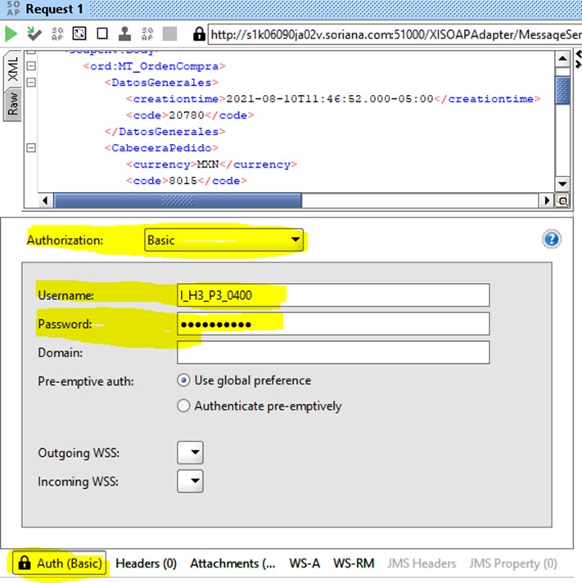
La autenticación básica se establece al abrir el panel Auth, con el botoncito marcado en amarillo en la región inferior izquierda del panel REQUEST.
Request: para orden 0000008015-4-0
<soapenv:Envelope xmlns:soapenv="http://schemas.xmlsoap.org/soap/envelope/" xmlns:ord="http://soriana.com/pi/sap_hybris_cloud/OrdenCompra">
<soapenv:Header/>
<soapenv:Body>
<ord:MT_OrdenCompra>
<DatosGenerales>
<creationtime>2021-08-10T11:46:52.000-05:00</creationtime>
<code>20780</code>
</DatosGenerales>
<CabeceraPedido>
<currency>MXN</currency>
<code>8015</code>
<creationtime>2021-08-10T11:46:59.000-05:00</creationtime>
<consignment>0000008015-4-0</consignment>
</CabeceraPedido>
<!--1 or more repetitions:-->
<DetalleTransferencia>
<consecutivo>1</consecutivo>
<code>11471453</code>
<unit>PCE</unit>
</DetalleTransferencia>
<!--1 or more repetitions:-->
<DetalleReparto>
<consecutivo>1</consecutivo>
<creationtime>2021-08-10T11:46:59.000-05:00</creationtime>
<quantity>1</quantity>
</DetalleReparto>
<!--1 or more repetitions:-->
<DireccionCEDIS>
<consecutivo>1</consecutivo>
</DireccionCEDIS>
</ord:MT_OrdenCompra>
</soapenv:Body>
</soapenv:Envelope>

Response: Si esta conectado a VPN
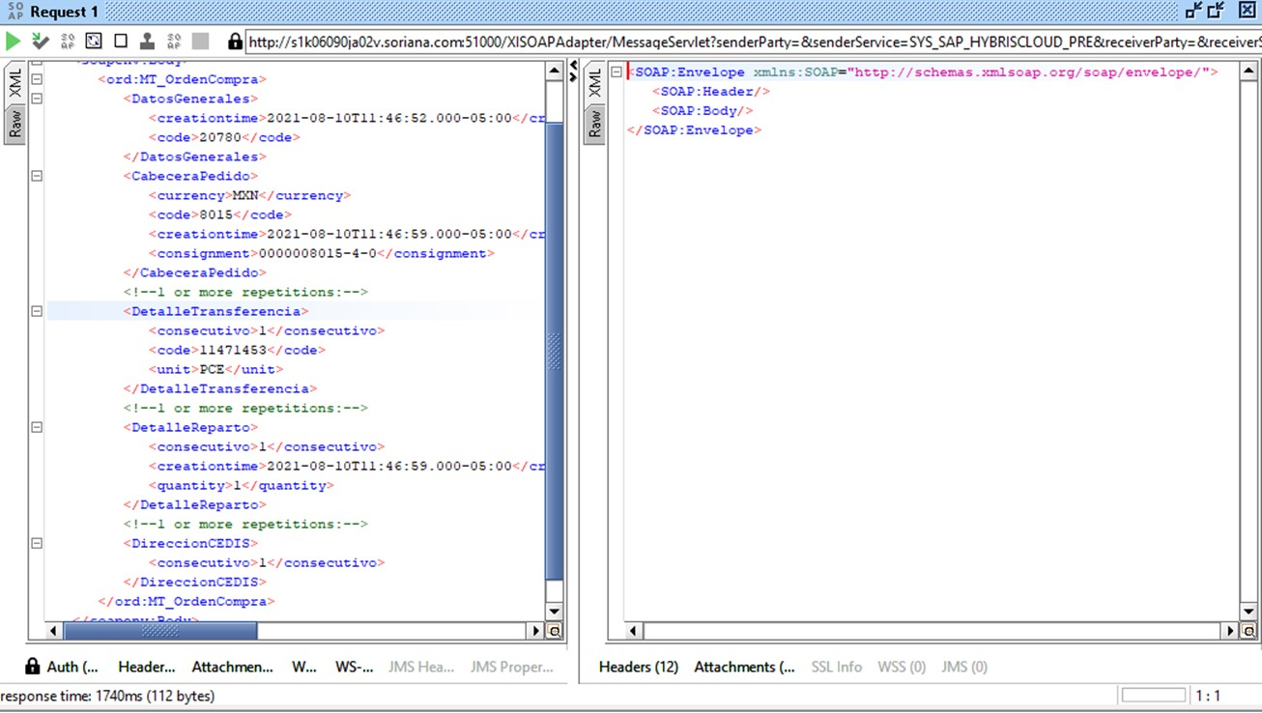

<SOAP:Envelope xmlns:SOAP="http://schemas.xmlsoap.org/soap/envelope/">
<SOAP:Header/>
<SOAP:Body/>
</SOAP:Envelope>

Mon Aug 23 13:28:11 CDT 2021:DEBUG:Attempt 1 to execute request
Mon Aug 23 13:28:11 CDT 2021:DEBUG:Sending request: POST /XISOAPAdapter/MessageServlet?senderParty=&senderService=SYS_SAP_HYBRISCLOUD_PRE&receiverParty=&receiverService=&interface=SI_OrdenCompra_OB&interfaceNamespace=http://soriana.com/pi/sap_hybris_cloud/OrdenCompra HTTP/1.1
Mon Aug 23 13:28:12 CDT 2021:DEBUG:Receiving response: HTTP/1.1 401 Unauthorized
Mon Aug 23 13:28:12 CDT 2021:DEBUG:Authentication required
Mon Aug 23 13:28:12 CDT 2021:DEBUG:s1k06090ja02v.soriana.com:51000 requested authentication
Mon Aug 23 13:28:12 CDT 2021:DEBUG:s1k06090ja02v.soriana.com:51000 requires authentication with the realm 'XISOAPApps'
Mon Aug 23 13:28:12 CDT 2021:DEBUG:Selected authentication options: [BASIC [complete=true]]
Mon Aug 23 13:28:12 CDT 2021:DEBUG:Connection 0.0.0.0:53244<->192.168.126.55:51000 closed
Mon Aug 23 13:28:12 CDT 2021:DEBUG:Attempt 2 to execute request
Mon Aug 23 13:28:12 CDT 2021:DEBUG:Sending request: POST /XISOAPAdapter/MessageServlet?senderParty=&senderService=SYS_SAP_HYBRISCLOUD_PRE&receiverParty=&receiverService=&interface=SI_OrdenCompra_OB&interfaceNamespace=http://soriana.com/pi/sap_hybris_cloud/OrdenCompra HTTP/1.1
Mon Aug 23 13:28:16 CDT 2021:DEBUG:Receiving response: HTTP/1.1 200 OK
Mon Aug 23 13:28:16 CDT 2021:DEBUG:Connection can be kept alive indefinitely
Mon Aug 23 13:28:16 CDT 2021:DEBUG:Authentication succeeded
Mon Aug 23 13:28:16 CDT 2021:INFO:Got response for [SI_OrdenCompra_OBBinding.SI_OrdenCompra_OB:Request 1] in 5162ms (112 bytes)
Mon Aug 23 13:28:47 CDT 2021:DEBUG:Connection 0.0.0.0:53245<->192.168.126.55:51000 closed

Response: Si NO esta conectado a VPN
Mon Aug 30 17:11:29 CDT 2021:DEBUG:Connection com.eviware.soapui.impl.wsdl.support.http.SoapUIMultiThreadedHttpConnectionManager$SoapUIDefaultClientConnection@1ef291e6 closed
Mon Aug 30 17:11:29 CDT 2021:DEBUG:Connection com.eviware.soapui.impl.wsdl.support.http.SoapUIMultiThreadedHttpConnectionManager$SoapUIDefaultClientConnection@1ef291e6 shut down
Mon Aug 30 17:11:29 CDT 2021:DEBUG:Connection com.eviware.soapui.impl.wsdl.support.http.SoapUIMultiThreadedHttpConnectionManager$SoapUIDefaultClientConnection@1ef291e6 closed
Mon Aug 30 17:11:29 CDT 2021:ERROR:Exception in request: java.net.UnknownHostException: s1k06090ja02v.soriana.com
Mon Aug 30 17:11:29 CDT 2021:ERROR:An error occurred [s1k06090ja02v.soriana.com], see error log for details
Mon Aug 30 17:11:29 CDT 2021:INFO:Error getting response for [SI_OrdenCompra_OBBinding.SI_OrdenCompra_OB:Request 1]; java.net.UnknownHostException: s1k06090ja02v.soriana.com

